**Module 2 Assignment: Variables and Constants with Arithmetic Calculations using Flowcharting**

**Exercise 2**

**A.Heirarchy Chart**

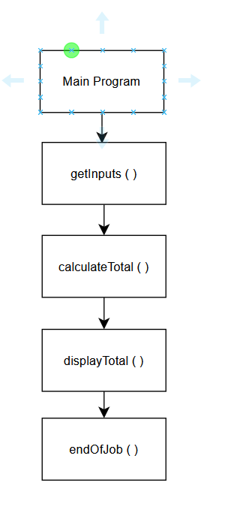

**B. Flowchart**

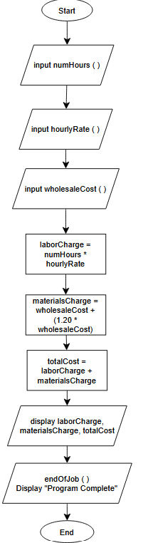

**C. Pseudocode**

**PROGRAM**

Main Module

Declare numHours, hourlyRate, wholesaleCost

Declare laborCharge, materialsCharge, totalCost

Call GetInputs()

Call CalculateTotal()

Call DisplayTotal()

Call EndOfJob()

End Main

GetInputs()

Display "Enter number of hours: "

Input numHours

Display "Enter hourly rate: "

Input hourlyRate

Display "Enter wholesale cost of materials: "

Input wholesaleCost

End GetInputs

CalculateCharges()

laborCharge = numHours * hourlyRate

materialsCharge = wholesaleCost + (1.20 * wholesaleCost)

totalCost = laborCharge + materialsCharge

End CalculateCharges

DisplayResults()

Display "Labor charge: $" + laborCharge

Display "Materials charge: $" + materialsCharge

Display "Total cost: $" + totalCost

End DisplayResults

EndOfJob()

Display "Program complete."

End EndOfJob